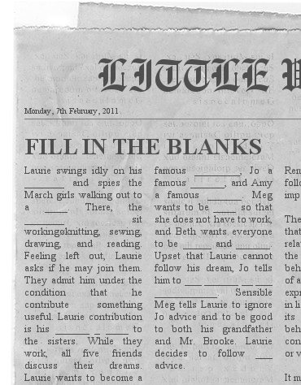
THE REAL ANSWER
Laurie swings idly on his hammock and spies the March girls walking out to a hill. There, the sisters sit working—knitting, sewing, drawing, and reading. Feeling left out, Laurie asks if he may join them. They admit him under the condition that he contribute something useful . Laurie’s contribution is his reading a book to the sisters. While they work, all five friends discuss their dreams. Laurie wants to become a famous musician, Jo a famous author, and Amy a famous artist. Meg wants to be rich so that she does not have to work, and Beth wants everyone to be happy and together. Upset that Laurie cannot follow his dream, Jo tells him to run away from his grandfather, who does not want him to be a musician. Sensible Meg tells Laurie to ignore Jo’s advice and to be good to both his grandfather and Mr. Brooke. Laurie decides to follow Meg’s advice
.

